2.2 Planning Proposal - Shiralee - Rezoning Hawke Lane Park
RECORD NUMBER: 2023/575
AUTHOR: Craig Mortell, Senior Planner

EXECUTIVE SUMMARY
Council is in receipt of a Planning Proposal that seeks to rezone an area informally referred to as Hawke Lane Park from RE1 Public Recreation to R1 General Residential and establish a minimum lot size for subdivision of 700m² to match the size of allotments that that Master plan advocates adjacent to agricultural land further south of Hawke Lane. It should be noted that Hawke Lane Park was originally identified for open space within the Shiralee DCP masterplan. This was primarily a response to safety issues arising from the presence of a large dam on the southern side of Hawke Lane. Council has subsequently acquired the land containing the large dam and drained it to remove the risk.
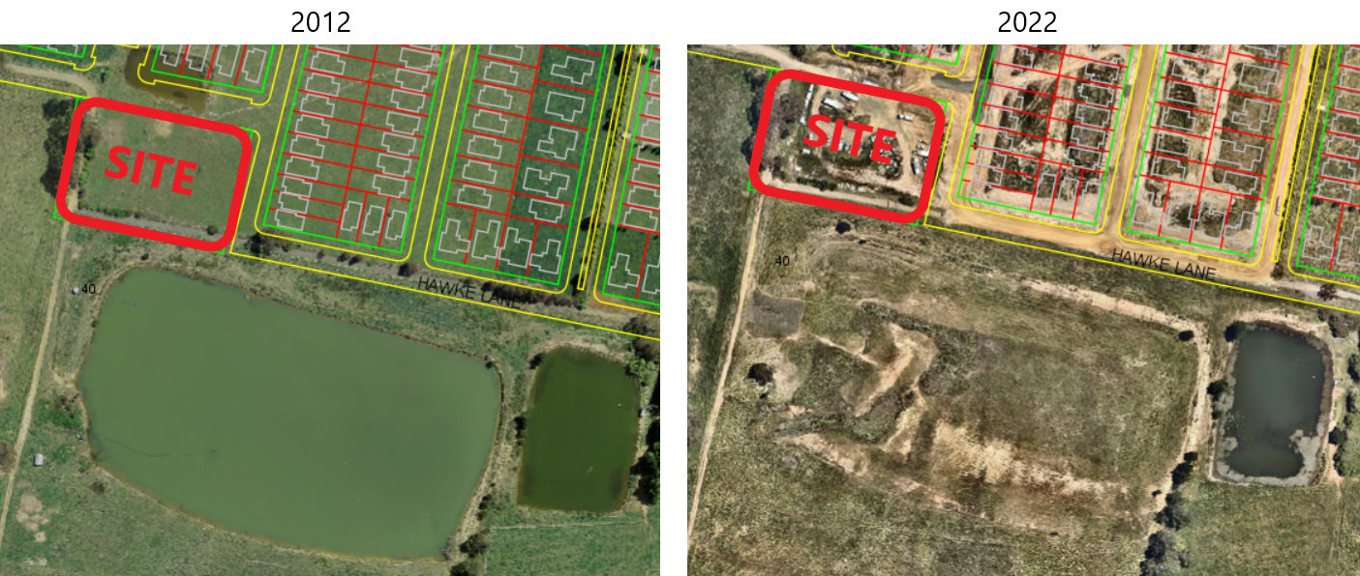
With the removal of the dam break flood risk, the justification for the open space zone has diminished. The dimensions of the site make it of limited value for recreation. The absence of vegetation makes it of negligible ecological value. The peripheral location of the site in the Shiralee context limits the number of residents that would derive passive amenity.
Conversely rezoning the site to residential land could result in up to 8 additional residential lots becoming available (subject to a separate Development Application). As the former dam is now in public (Council) ownership it is considered that the underlying potential of the land for housing represents a better outcome that will make a modest contribution to availability.
The attached Planning Proposal document, while light on detail, has addressed the range of matters required by the NSW Department of Planning and Environment guidelines. A gateway determination may impose conditions requiring additional studies or information prior to agency and public consultations.

LINK TO DELIVERY/OPERATIONAL PLAN
The recommendation in this report relates to the Delivery/Operational Plan strategy “7.1. Engage with the community to develop plans for growth and development that value the local environment”.

FINANCIAL IMPLICATIONS
Nil

POLICY AND GOVERNANCE IMPLICATIONS
Nil

Recommendation
- That Council support the planning proposal and forward the matter to the NSW Department of Planning and Environment for a Gateway Determination.
- That, subject to a favourable gateway determination, staff commission any additional studies or information required to enable the proposal to proceed to agency and public consultation with such work to be at the proponents cost.

FURTHER CONSIDERATIONS
Consideration has been given to the recommendation’s impact on Council’s service delivery; image and reputation; political; environmental; health and safety; employees; stakeholders and project management; and no further implications or risks have been identified.

SUPPORTING INFORMATION
The Shiralee DCP Masterplan sets out a vision for development of land bounded by the railway corridor, Pinnacle Road, Hawke Lane and the DPI Bloomfield precinct to the east. Shiralee is intended to deliver approximately 1,750 residential lots across a mix of lot sizes within a high quality urban environment. A diverse range of recreation and open spaces are included within the masterplan to promote active healthy lifestyles and encourage alternative travel modes.

With a size of 7,436m² being approximately 70m x 100m inclusive of Hawke Lane road reserve to the west and south of the proponents land (approximately 5,716m² or 58m x 90m without the road reserve) the dimensions limit the range of active recreation facilities that could be accommodated. Additionally, the peripheral location of the park will both limit visitation rates and reduce the contribution to pedestrian / cyclist linkages. From a recreational perspective (both active and passive) the park is not considered to be a significant component of the open space network within Shiralee.

With regards to ecological values the site is clear of vegetation and has been used informally as a parking area during the subdivision works occurring elsewhere on the site. There are a few native trees in the Hawke Lane road reserve, however the site does not otherwise adjoin or link to remnant vegetation or habitat areas.

Under used open space lands can sometimes present opportunities for tree planting to increase urban forest and canopy cover. Such planting sites can in time contribute to ecological values, however the isolated location of Hawke Lane Park will always limit the potential in this respect.

Within this context it can be seen that Hawke Lane Park was originally identified primarily as a response to safety issues arising from a large dam on the southern side of Hawke Lane. In the event of a dam failure a substantial area would be inundated. To address this it was considered that land shaping could use Hawke Lane to divert much of this water towards the “park” from where it would then flow north along a wide boulevard “Green Street” to reach a larger detention basin south of Shiralee Road.

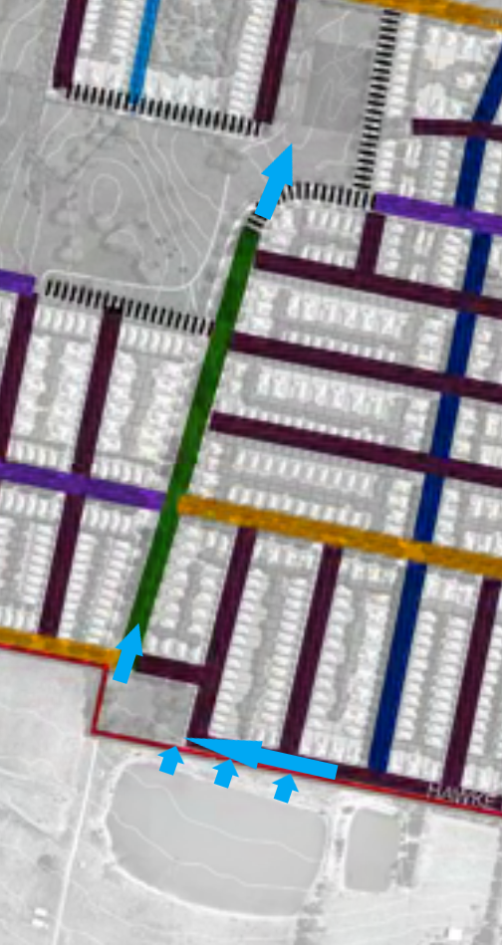

Council subsequently acquired the dam on the south side of Hawke Lane and drained this feature to remove the potential safety risk. This has removed much of the justification for the RE1 zoning of the subject site.
Conversely the suitability of the land for residential subdivision is based on being essentially flat (sloping gently to the east), clear land that directly adjoins the emerging subdivision. Being on the north side of the road means that Hawke Lane will continue to provide the natural limit to the urban footprint of Shiralee and will not place further pressure on the adjoining farmland to the south.
An additional ~8 residential lots will make a minor contribution to the available supply of residential land in Orange and modest boost to the contributions plan funds.

Strategic Justification
The Planning Proposal has responded to relevant provisions within the NSW Governments Central West and Orana Regional Plan 2041 (CWORP) to provide additional supply of residential land and housing. Strategy 13.1 promotes new housing capacity where it can use existing infrastructure and it can be reasonably assumed that this would include making more efficient use of new infrastructure being installed for the adjoining subdivision.
The proposal argues for a net community benefit in the form of additional housing opportunities, noting that it can be serviced at negligible additional cost and contrasts this with the loss of 5,716m² of public recreation land (excluding the road reserve to the west and south of the proponents land) which was originally intended for stormwater / flood mitigation purposes leaving a very small area available that was not constrained. The proposal notes the proximity of other open space areas. Hill Top Park is approximately 380m to the north which leads into further open space and parkland areas north from there.
The Planning Proposal provides a brief overview of how the project relates to the strategic planning framework in NSW including State Environmental Planning Policies, Section 9.1 Ministerial Directions.
The document has mistakenly claimed that Direction 5.2 is not applicable to the proposal. This direction states:
(4) A planning proposal must not create, alter or reduce existing zonings or reservations of land for public purposes without the approval of the relevant public authority and the Director-General of the Department of Planning (or an officer of the Department nominated by the Director-General).
Clearly the proposal does reduce the existing RE1 zone. As such the proposal requires the approval of both Council and the Director-General of the Department of Planning. It is therefore likely that a gateway determination will seek additional information or justification on this point. However, as discussed in this report the value of this site for public recreation or ecological purposes is considered to be minimal and the main reason for the zones creation, that of mitigating flood inundation risks, has essentially been removed. On this basis it is considered that the proposal is likely to satisfy Ministerial Direction 5.2
Environmental, social and economic impacts are each considered to be minor and unlikely to justify retention of the RE1 zone. Community consultation will be undertaken in accordance with any Gateway Determination. Public Agency consultations are not anticipated although being on the rural interface it is possible that the Gateway Determination will nominate NSW DPI.
Conclusion
The proposal represents a minor reduction in public open space in order to achieve a minor increase in residential supply. The existing RE1 Public Recreation zone was established primarily to mitigate flood inundation risks that subsequent events have effectively removed. The remaining open space “value” of the site is minimal both in recreation and ecological terms. The site will not expand the urban footprint of Shiralee, remaining within the Hawke Lane boundary, and as such does not increase the urban-rural interface. The current residential development in the area is extending infrastructure and services to the area such that there is negligible cost to incorporate this land.
The land itself is relatively flat and unconstrained (given the removal of the Hawke Lane dam). Councils recently adopted Local Housing Strategy respects and supports the intent of Shiralee and does encourage infill opportunities where appropriate. For these reasons it is considered appropriate to support the proposal and seek a Gateway Determination.

Attachments
1 Planning Proposal, D23/26923
2 Mapping, D23/26925

